DEALER DEMO PROGRAM
Company Name: Date:
Contact Name: Sales Rep:
Email Address: Rep Firm:
Phone Number:
Billing To: Shipping To:
Address: Address:
Suite#: Zip: Suite#: Zip:
City: State: City: State:
Phone Number: Phone Number:

Unit | Description | Item ID | Unit Price | Quantity | Total
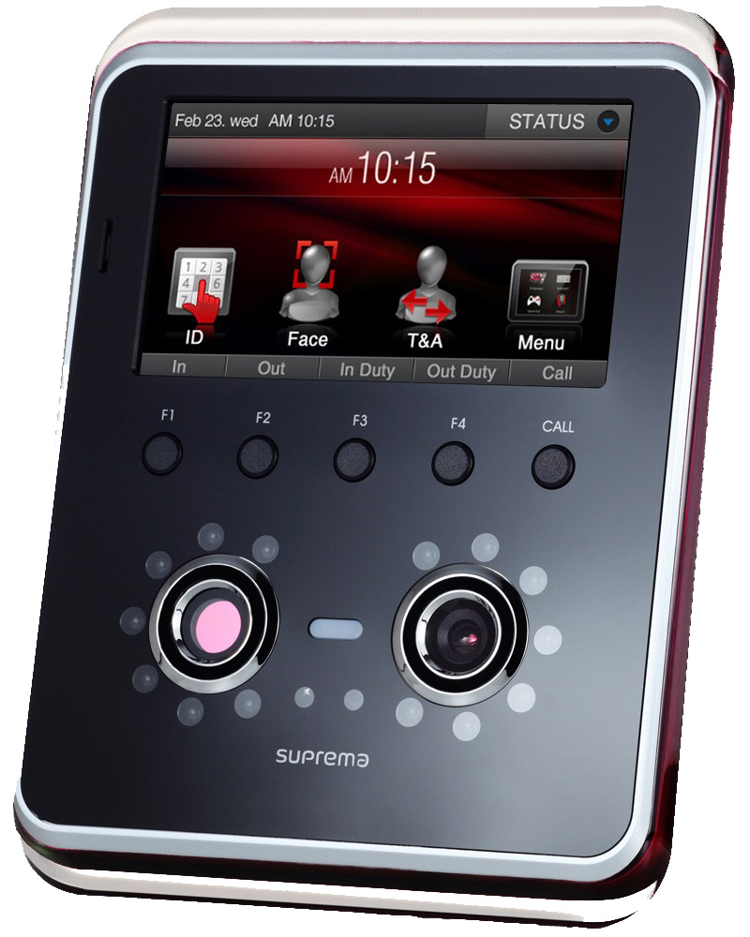 | FaceStation Kit (Includes Reader, Power Supply) | DK-FSM-OC | $1,645.00
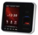 | Biostation T2 Mifare Kit (Includes Reader, Power Supply, Table top Stand, 1 Mifare card, BioStar SE Software) | DK-BST2M-OC | $1045.00
 | BioLite Net (Mifare) Kit (Includes Reader, Power Supply, Tabletop Stand) | DK-BLN-OC | $645.00
 |  |  | Subtotal
Demo Kits are for Dealer Testing and DEMO ONLY Strictly NOT FOR RESALE |  |  | Total

Method of Payment
Visa Mastercard
Card Number: Exp. Sec:
Name on Card: Signature:

Please forward all orders to sales@entertechsystems.com

